**Project report**

**Submitted By: Group-6**

|  |  |
| --- | --- |
| **NAME** | **SID** |
| Munna Biswas | 221-15-5261 |
| Mahfujur Rahman | 221-15-4691 |
| Mehnaz Afsana | 221-15-5693 |
| Akib Shahriar | 221-15-5485 |
| Sweety Akter | 221-15-4833 |

**Project Title:** **ShowCase (**ASkill sharing platform**)**

**Github Link:** [**https://github.com/munnabiswas99/ShowCase**](https://github.com/munnabiswas99/ShowCase)

**Website Link:** [**https://munnabiswas99.github.io/ShowCase/**](https://munnabiswas99.github.io/ShowCase/)

**Contributions:**

**Community Page:**

Munna Biswas- [221-15-5261]

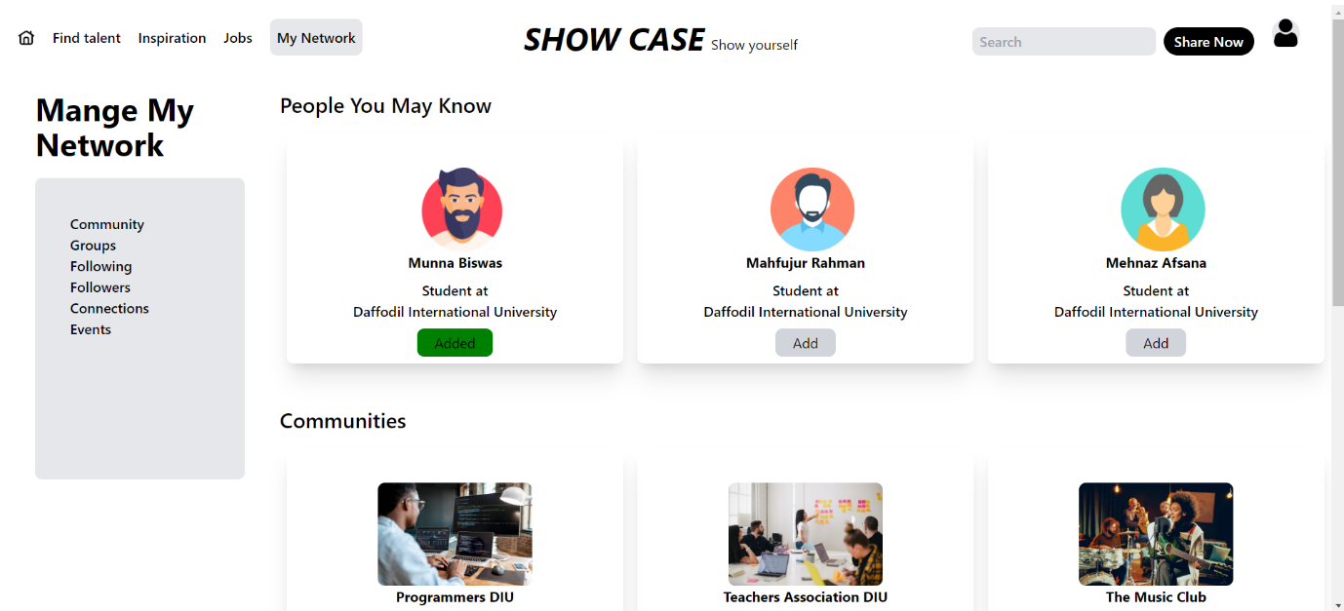

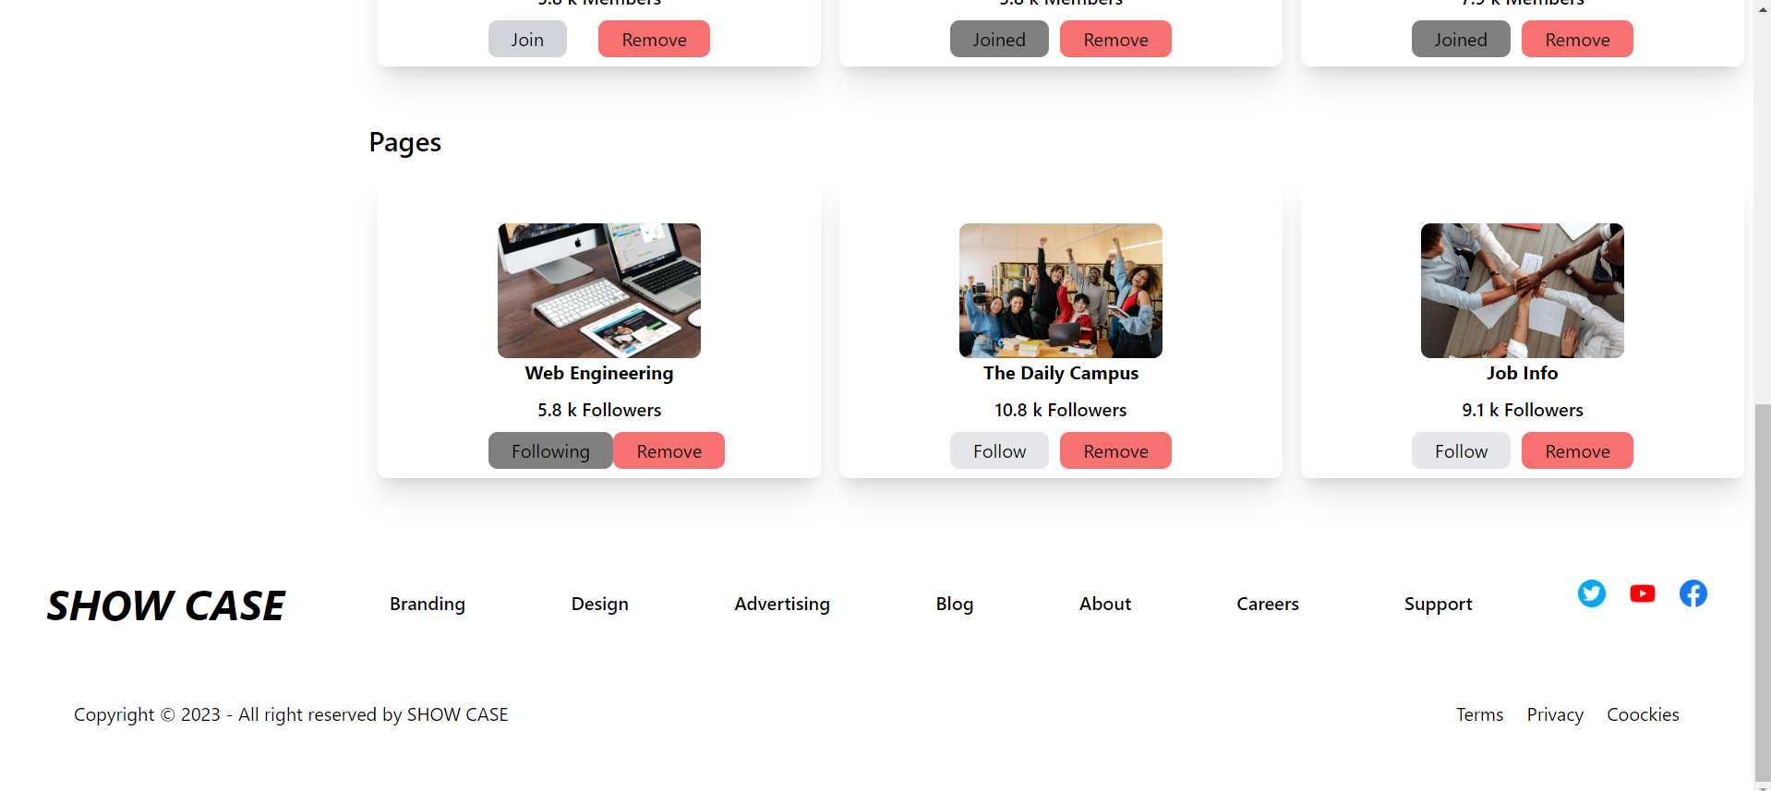

**Home Page:**

Mahfujur Rahman- [221-15-4691]

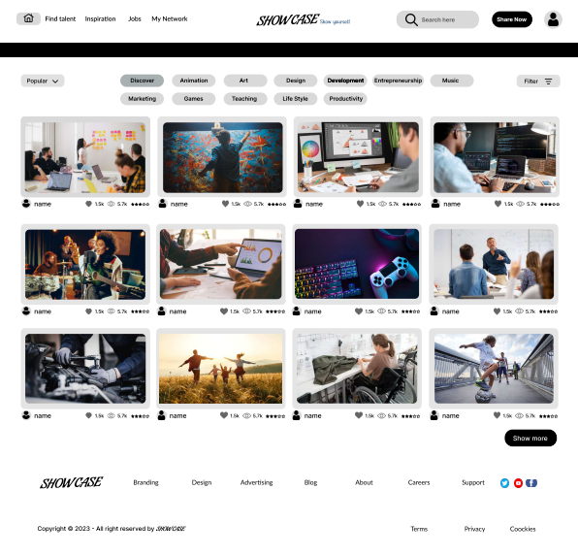

**SignUp Page:**

Mehnaz Afsana- [221-15-5693]

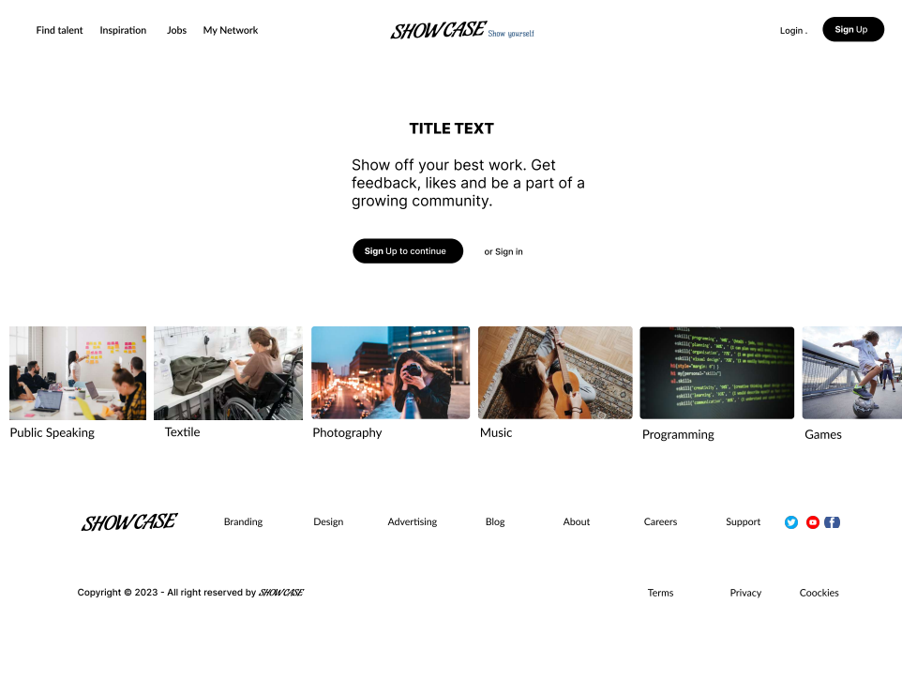

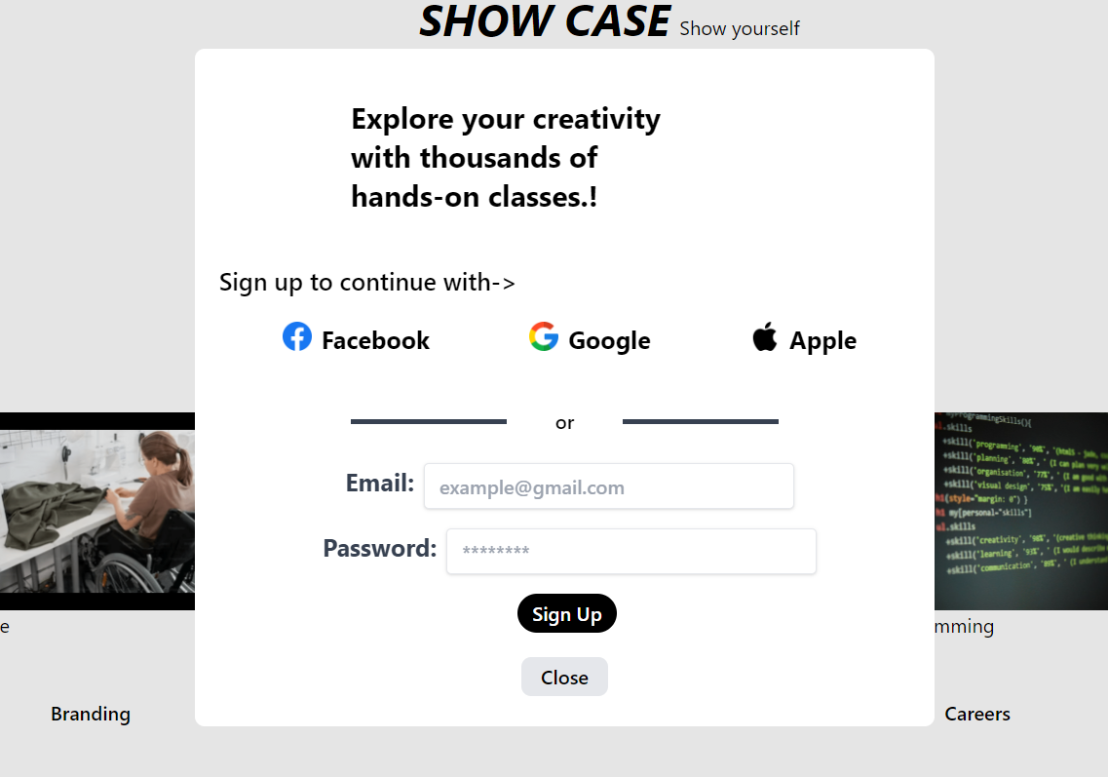

**Profile Page:**

Akib Shariar- [221-15-5485]

